**Lab Report. 02**

**Title: Lab Report**

*Course title: Computer Graphics Lab*

*Course code: CSE-304*

*3rd Year 1st Semester 2022*

**Date of Submission**: 04/06/2023



###### **Submitted to-**

###### Dr. Mohammad Shorif Uddin

###### Professor

*Department of Computer Science and Engineering*

*Jahangirnagar University*

*Savar, Dhaka-1342*

*And*

*Dr. Morium Akter*

###### Associate Professor

*Department of Computer Science and Engineering*

*Jahangirnagar University*

*Savar, Dhaka-1342*

|  |  |  |  |
| --- | --- | --- | --- |
| **Sl** | Class Roll | Exam Roll | Name |
| 01 | 367 |  | Fatima Binte Aziz |

Source code:

#include <graphics.h>

void drawCircle(int centerX, int centerY, int radius)

{

int x = 0;

int y = radius;

int decision = 1 - radius;

while (y >= x)

{

putpixel(centerX + x, centerY + y, YELLOW);

putpixel(centerX + y, centerY + x, YELLOW);

putpixel(centerX - y, centerY + x, YELLOW);

putpixel(centerX - x, centerY + y, YELLOW);

putpixel(centerX - x, centerY - y, YELLOW);

putpixel(centerX - y, centerY - x, YELLOW);

putpixel(centerX + y, centerY - x, YELLOW);

putpixel(centerX + x, centerY - y, YELLOW);

if (decision < 0)

{

decision += 2 * x + 3;

}

else

{

decision += 2 * (x - y) + 5;

y--;

}

x++;

}

}

int main()

{

int gd = DETECT, gm;

initgraph(&gd, &gm, "");

int centerX = 444;

int centerY = 222;

int radius = 100;

drawCircle(centerX, centerY, radius);

getch();

closegraph();

return 0;

}

Output:

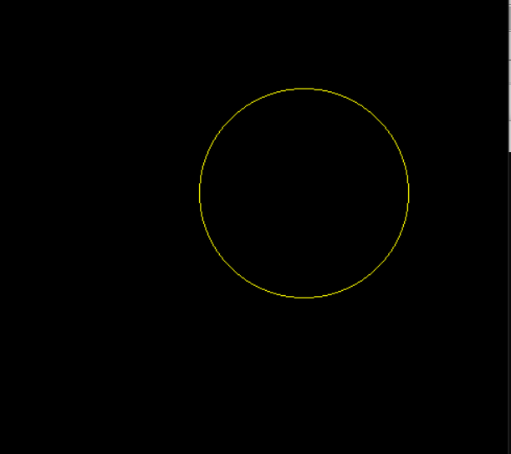

Source code:

#include <graphics.h>

void drawEllipse(int centerX, int centerY, int radiusX, int radiusY)

{

int x = 0;

int y = radiusY;

int aSquare = radiusX * radiusX;

int bSquare = radiusY * radiusY;

int decision = bSquare + aSquare * (0.25 - radiusY);

while (bSquare * x <= aSquare * y)

{

putpixel(centerX + x, centerY + y, YELLOW);

putpixel(centerX - x, centerY + y, YELLOW);

putpixel(centerX - x, centerY - y, YELLOW);

putpixel(centerX + x, centerY - y, YELLOW);

if (decision < 0)

{

x++;

decision += bSquare * (2 * x + 3);

}

else

{

x++;

y--;

decision += bSquare * (2 * x + 3) + aSquare * (-2 * y + 2);

}

}

decision = bSquare * (x + 0.5) * (x + 0.5) + aSquare * (y - 1) * (y - 1) - aSquare * bSquare;

while (y >= 0)

{

putpixel(centerX + x, centerY + y, YELLOW);

putpixel(centerX - x, centerY + y, YELLOW);

putpixel(centerX - x, centerY - y, YELLOW);

putpixel(centerX + x, centerY - y, YELLOW);

if (decision > 0)

{

y--;

decision += aSquare * (-2 * y + 3);

}

else

{

y--;

x++;

decision += bSquare * (2 * x + 2) + aSquare * (-2 * y + 3);

}

}

}

int main()

{

int gd = DETECT, gm;

initgraph(&gd, &gm, "");

int centerX = 320;

int centerY = 340;

int radiusX = 200;

int radiusY = 100;

drawEllipse(centerX, centerY, radiusX, radiusY);

getch();

closegraph();

return 0;

}

Output:

